Structure of the Paper
Title
Abstract, keywords
1. Introduction
2. Literature review & Major contributions in 5 points
3. Dataset overview & Augmentation (add dataset class-wise description table, dataset sample images)
4. Description of proposed model architecture (add overview diagram)
5. Results and Discussion (add all plots, big performance metrics table of your proposed model)
6. Ablation study (add one comparison table)
7. Qualitative comparative analysis of proposed model wrt existing models (add mAP vs Parameter plot in Origin Pro)
8. Deployment on edge device (Raspberry Pi specs, add setup photo)
9. Conclusion
10. References
Note: But do not start writing the paper in the above order. First, begin with the most important section of your paper, which is Section 5: Results and Discussion. Reviewers are primarily interested in the obtained results and their explanations; therefore, this section must be written very effectively. Next, write Section 6: Ablation Study, followed by Section 8: Hardware Deployment.

You have to strictly follow this order while writing the paper:
Section 5. Results and Discussion
Section 6. Ablation study
Section 8. Deployment on edge device
Section 7. Qualitative comparative analysis
Section 4. Description of proposed model architecture
Section 3. Dataset overview & Augmentation
Section 2. Literature review
Section 1. Introduction
Finally write these: major contributions, frame a good title, write abstract and conclusion
Check whether all reference citations given in Literature review, Qualitative comparative analysis and introduction sections.

Begin writing the content from here
Suggestion: Keep the table (before & after augmentation, hybridisation without AI & hybridization with AI results) with all performance metrics (mAP 0.5, mAP 50-95, Parameters, Precision, Recall, inference time, GFLOPs) ready.
Note: First open a new chat (better use chatgpt 5.2 or better version) and give the dataset description first. You have to go to the source from where you have collected the dataset for dataset description.
Dataset description:
Prompt: Analyze the dataset description in detail. Analyze the distinct classes available in the dataset and also analyse if class imbalance etc.
Note: Next, let know what model you are using.
Prompt: I have used Yolov5s for object detection and this is the yaml code (give the model summary/ yaml file code):
Note: Next, you have to write the Results and Discussion section. Mainly focus on the results (performance metrics) you obtained, why you obtained these results, and the in-depth reasons behind your model producing such outcomes.
Section. 5 Results & Discussion
Note: Give brief description of your local workstation specifications, training splits, Python version, framework details etc.
- Performance analysis Before Augmentation: (1 paragraph 250 words)
Prompt: These are the results (confusion matrix and Precision-recall curve) obtained by the baseline YOLOv11n model (give yaml code). The obtained mAP0.5 is 5.7 and the parameter count is 2.56Million. Perform class-wise analysis & which are the poor performing classes and best performing classes and give the in-depth reasons why & how the model has given such overall mAP0.5. What component/blocks of the baseline YOLOv11n model has contributed to the obtained mAP0.5 and also why the model performed poor in some classes.

- Performance analysis After augmentation (1 paragraph 150 words)
Prompt: We have augmented the dataset using .......... techniques (give augmentation code).
Prompt: These are the results (confusion matrix and Precision-recall curve) obtained by the baseline YOLOv11n model after augmentation. The obtained mAP0.5 is 98.7 and the parameter count is 2.56Million. Perform class-wise analysis & give the in-depth reasons why & how the model has given such overall mAP0.5 after augmentation. Analyze how the augmentation techniques have contributed to the enhanced mAP0.5 compared to mAP before augmentation.

- Performance analysis After hybridization (without AI domain included) (1 paragraph 300 words)
Note: We have to discuss only about the proposed optimal (trade-off) configuration which we have obtained among the 5 to 6 configurations you have put in ablation study. Now you have to give the code of that proposed model. And frame a good name for your proposed model (based on the main impactful blocks in ur model, something like this: DA‐ActNN‐YOLOV5…….)
Prompt: I have performed the architectural changes in the baseline Yolov11n model as per this yaml code. This is the hybridized model (give Yaml code). Analyze the hybridized architecture of the model. These are the results (confusion matrix and Precision-recall curve) obtained by the hybridized model. The obtained mAP0.5 is 98.7 and the parameter count is 1.3 Million. Perform class-wise analysis & give the in-depth reasons why & how the model parameters count has been reduced significantly while achieving the optional mAP0.5 after hybridization along with the contribution of the AI domain used. Analyze what blocks contributed in making the model lightweight with lowest parameter count while achieving the optional mAP0.5.
- Performance analysis After hybridization (with AI domain included) (1 paragraph 300 words)
This is the hybridized model with the AI domain included. Analyze how AI Domain has been included in the overall framework. These are the results (confusion matrix and Precision-recall curve) obtained by the hybridized model. The obtained mAP0.5 is 98.7 and the parameter count is 1.3 Million. Perform class-wise analysis & give the in-depth reasons why & how the integration of AI domain has impacts the results obtained.

- Performance metrics Analysis (1 paragraph 200 words)
Prompt: Further analyze the impact of the hybridized model on the Parameter count, inference time, and GFLOPs. Highlight the suitability of the lightweight proposed model for edge deployment.

Note: Add Confusion Matrix, Precision vs recall plot, Predictions labels, Labelling and bounding box positions & training and validation losses of each sub-section above
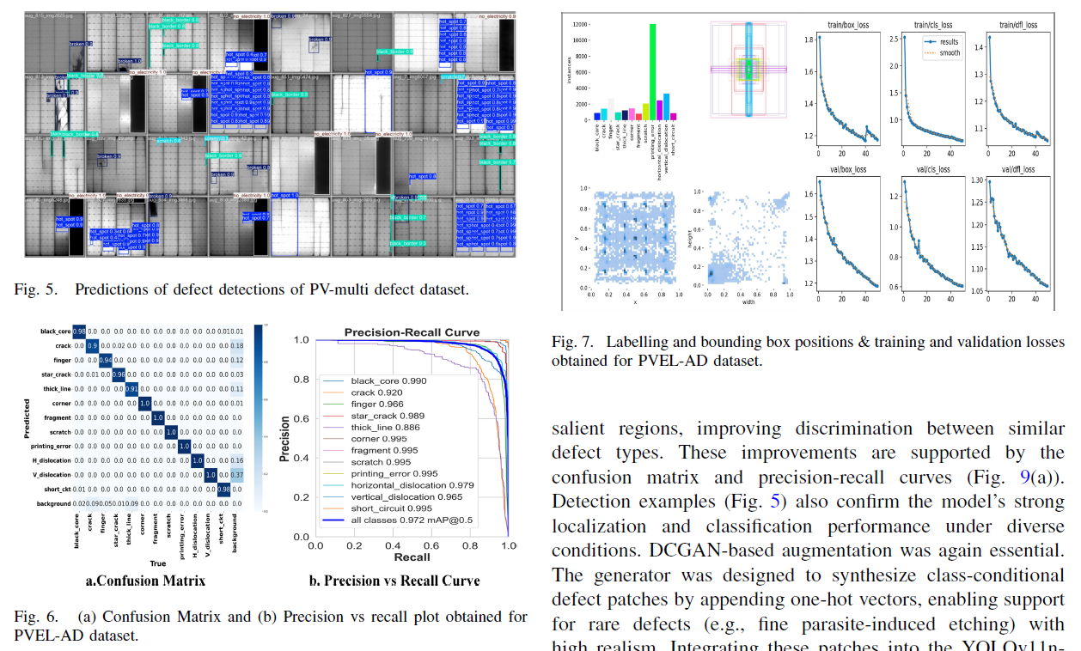

Section. 6 Ablation Study
Ablation study (2-3 paragraph 650 words)
Prompt: I want to perform the ablation study. I have tried 5 different configurations. Now i will give different configurations analyze them one by one, their impact on the obtained mAP0.5 and the parameter count how this configuration & what component of this configuration has resulted in the obtained mAP0.5 and parameter count.

Prompt: This is the code of configuration-1 'give yaml code'. Give one specific name of this particular model. Analyse it's impact on mAP and parameter count.

Prompt: This is the code of configuration-2 'give yaml code'. Give one specific name of this particular model. Analyse it's impact on mAP and parameter count.

Prompt: This is the code of configuration-3 'give yaml code'. Give one specific name of this particular model. Analyse it's impact on mAP and parameter count.
Prompt: This is the code of configuration-4 'give yaml code'. Give one specific name of this particular model. Analyse it's impact on mAP and parameter count.
Prompt: This is the code of configuration-5 'give yaml code'. Give one specific name of this particular model. Analyse it's impact on mAP and parameter count.
Note: Keep the table (all the different configurations u tried) with all performance metrics (mAP 0.5, mAP 50-95, Parameters, Precision, Recall, inference time, GFLOPs) ready.
Prompt: This is the table ‘give the table’ consisting of 5 different configurations that I have tried with the obtained performance metrics. Among the 5 configurations, the fifth confirmation is considered as the best one due to its balance trade off solution between the mAP0.5 and parameter count.
Note: Add a table in paper at the end of this section showing all configurations and their performance metrics.
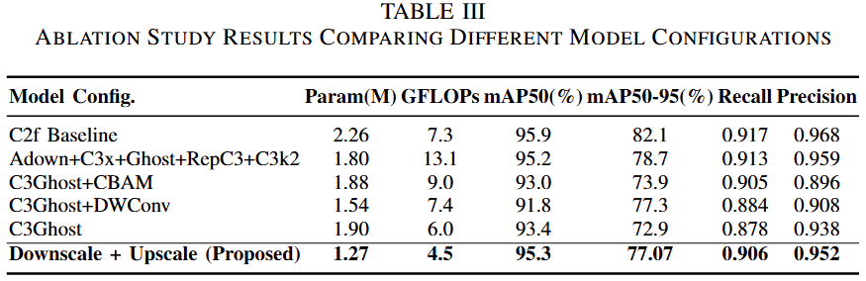

Section.7 Qualitative comparative analysis
Note: Keep the table (results of all different models from 4-7 existing papers) with all performance metrics (mAP 0.5, mAP 50-95, Parameters, Precision, Recall, inference time, GFLOPs) ready.
- Qualitative & Quantitative comparative analysis (2-3 paragraphs 650 words)
Prompt: Perform a detailed comparative analysis of the proposed model with the existing models. Highlight and analyse how the proposed model/framework is highly effective in mAP with very lightweight compared to each existing model. Give a brief paragraph for each model comparison. Include the citation references of the existing models in table as well as in discussion.
Note: Add a table in paper at the end of this section showing all existing model performance metrics along with the reference citations.
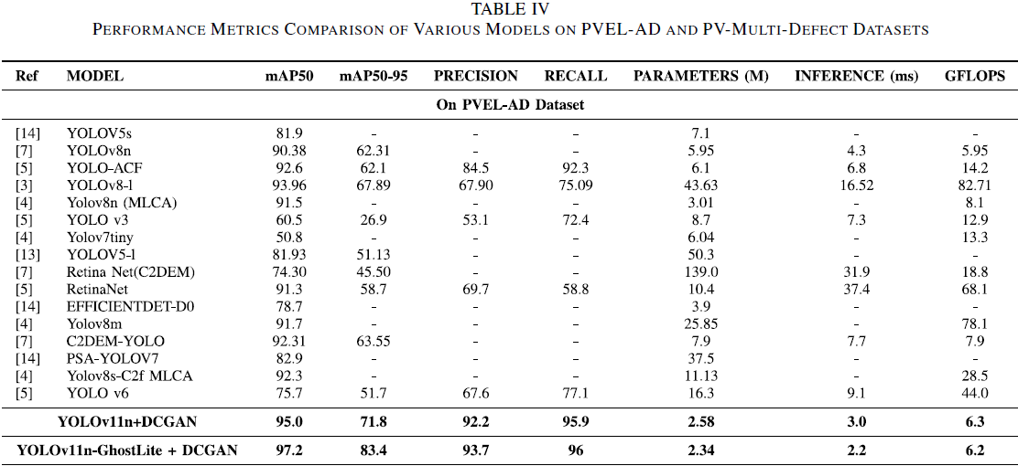
Section.8 Hardware Deployment
Deployment on Edge computing devices.
You can put any one of the following section headings for this particular section. Explore for any other good headings also.
- Edge Hardware Implementation and Validation on Embedded Platforms
- Hardware Validation and Edge-AI Deployment Analysis
- Real-Time Edge-AI Deployment and Hardware Validation on Embedded Devices
- Experimental Hardware Validation on Resource-Constrained Edge Platforms
- Edge-AI Hardware Validation and Real-Time Deployment Performance
- Real-Time Edge-AI Deployment and Hardware Performance Evaluation
- Implementation and Hardware Validation on Edge Platforms

The following subsections should be included in this section:
- A. Experimental Setup and Hardware Specifications (of both the boards)
- B. Edge Deployment on Raspberry Pi
- C. Edge Deployment on NVIDIA Jetson Orin Nano (discuss about inference latency across PyTorch (CUDA), FP32, FP16, and INT8 ONNX execution modes)
- D. Comparative Performance Analysis
Prompt: These are the results (give the screenshot of inference time) obtained by deploying the proposed model on Raspberry Pi/NVIDIA Jetson Orin Nano. Perform the analysis of the inference time obtained by the proposed model and also highlight how the lightweight nature of the proposed model yielded the fast inference time.
Prompt: Write one brief paragraph on inference time on Raspberry Pi (in 100 words) and a paragraph on inference time on NVIDIA Jetson Orin Nano (in 200 words) and the comparative performance analysis of raspberry pi/NVIDIA Jetson Orin Nano (in 150 words).
Add the overall setup diagrams, specifications table of Raspberry & Jetson, inference metrics in table.
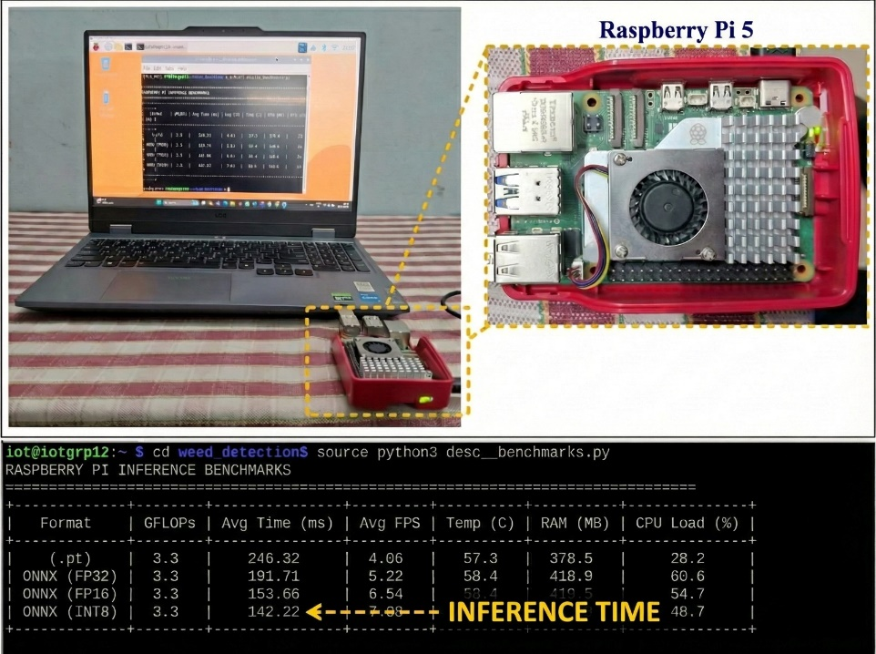
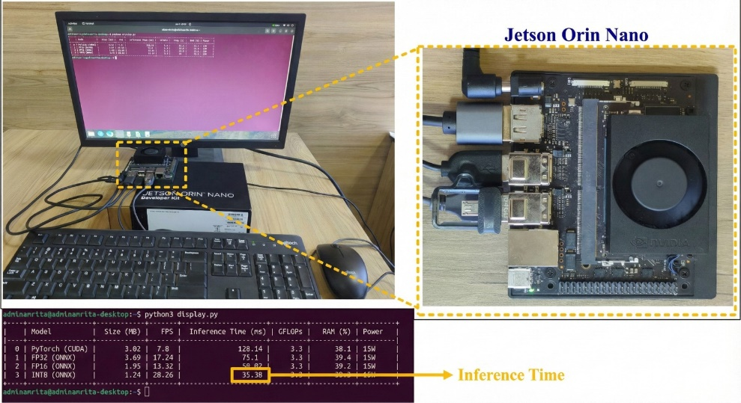

Section-4 Proposed Framework
Proposed YOLO model architecture
Prompt: This is the yaml code of the proposed model. Give the description of the proposed model architecture in detail with strong mathematical rigor. Give in paragraphs with side headings and with strong mathematical rigor. Emphasis the description of the specialized blocks used in the architecture. Finally highlight how this proposed architecture is different and efficient from the baseline model.

Prompt: Give the description of the AI domain (write the name of AI domain used) used in the proposed pipeline. This is the code ‘insert the code’. Give the description and the usage of the AI domain (write the name of AI domain used) used in the proposed pipeline in detail with strong mathematical rigor.
- Draw the overall framework with AI domain included.
- Draw the detailed hybridized model architecture with the internal diagrams of specialized blocks.
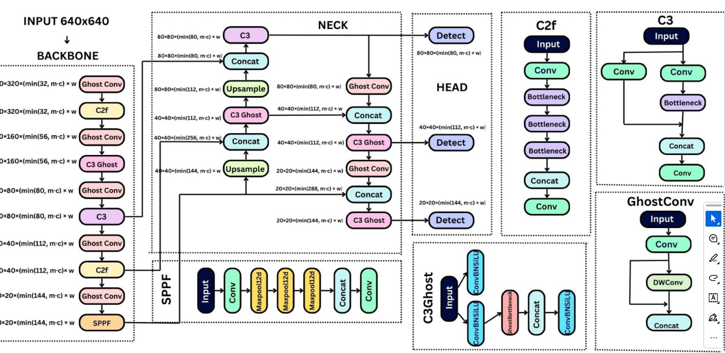
Section-3 Dataset Overview and Augmentation
Prompt: Give the description of the dataset in a paragraph.
Put some sample images & various classes in table in the paper.
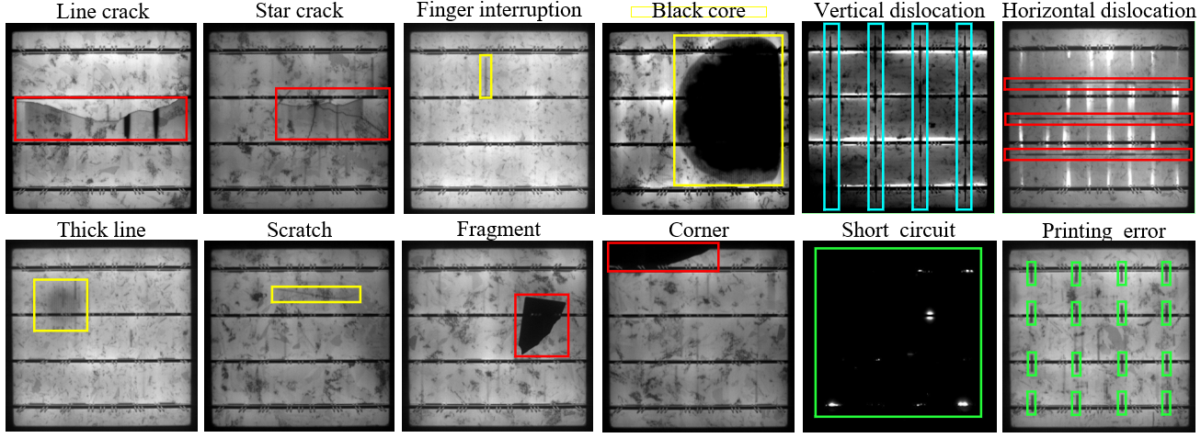
Prompt: We have augmented the dataset using .......... techniques (give augmentation techniques code). Give the description of the augmentation techniques used with strong mathematical rigor and equations
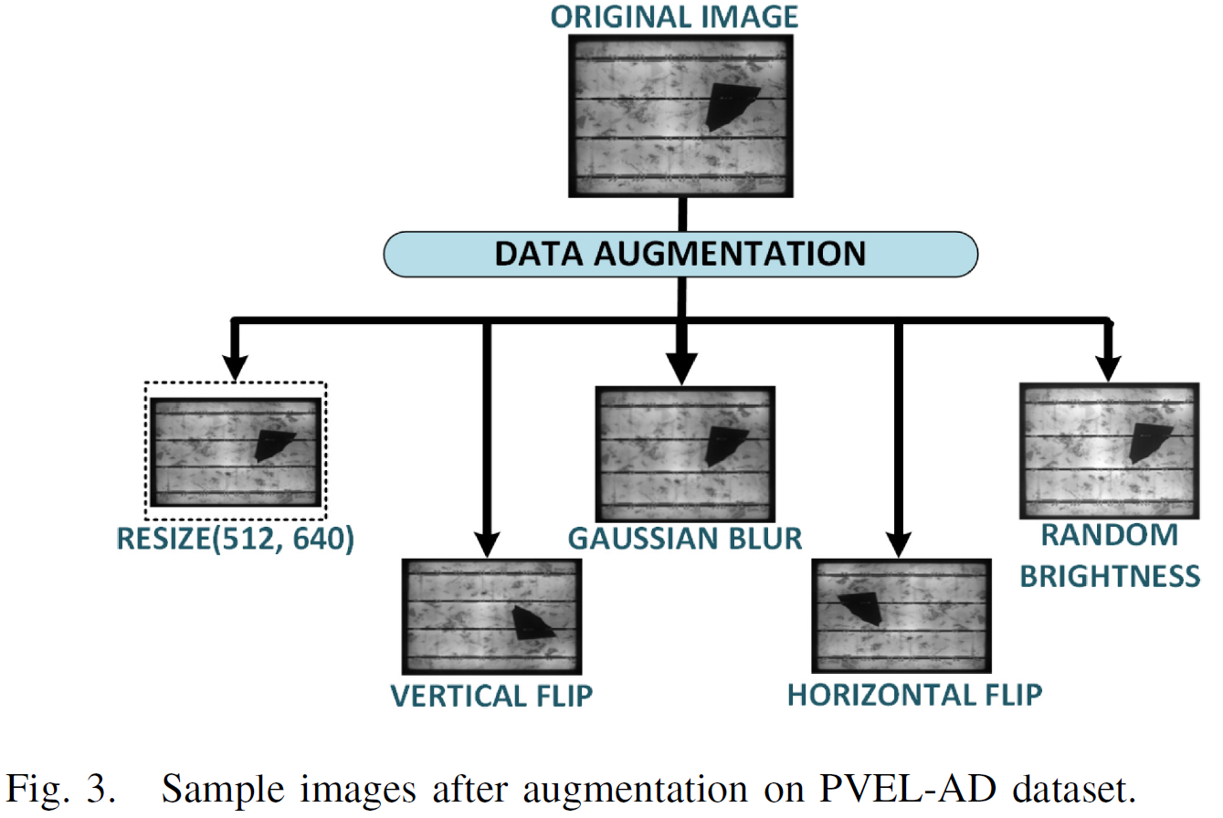
Section-2 Literature Review
Literature Review: Description of work done, model used, advantages & limitations (wrt proposed work).
Take 16-18 related (only Q1-Q3) journal papers from google scholar (papers used your dataset should be must included).
Prompt: Give the description of work done, model used, advantages & limitations (wrt my proposed model) for Paper-1.
Give the description of work done, model used, advantages & limitations (wrt my proposed model) for Paper-2.
Give the description of work done, model used, advantages & limitations (wrt my proposed model) for Paper-3.
Give the description of work done, model used, advantages & limitations (wrt my proposed model) for Paper-4……………………till paper-18
Gather all the content from these 18 papers for framing the literature review.
Prompt: This is the literature review content gathered from 18 papers. Give the literature review in a table format mentioning the refrence & year, description of work done, model used, advantages & limitations (wrt proposed work). Include the reference citations also for each paper.
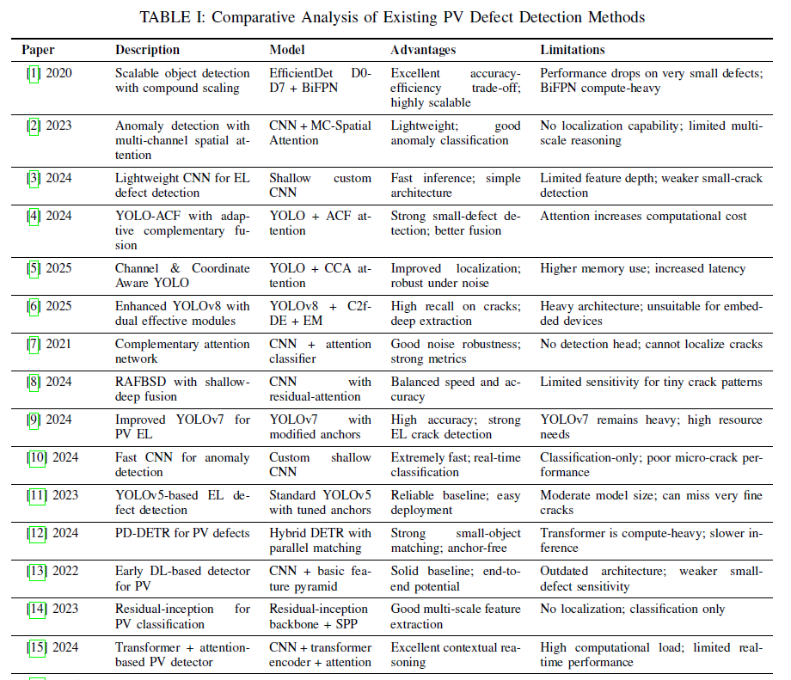
Section-1 Introduction
Prompt: Give the generic introduction & background of the research problem. How different methods have been used to solve the problem? And how AI and Deep learning and yolo has been instrumental in solving it. And still what are the problems with Yolo and hence what is the need/motivation for the proposed framework.

Major contributions- put it at the end of literature review
Prompt: Give the major contributions of the overall work in 5 brief paragraphs.
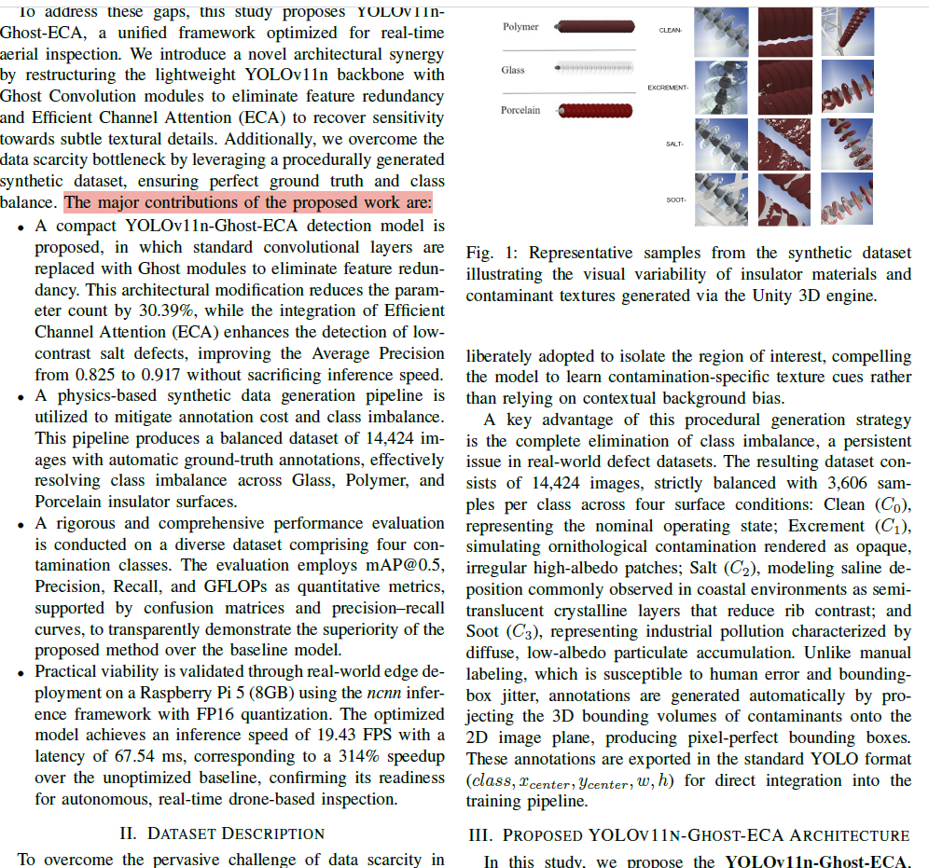

Abstract, conclusion and Title.
Prompt: Give the abstract section of the paper (in one paragraph, 200 words)
Prompt: Give the conclusion section of the paper (in one paragraph, 225 words)

